Bean Autowiring
By Type
ReportCreator.java
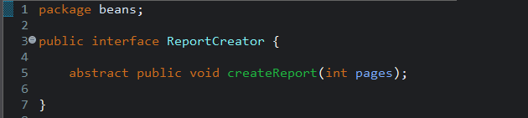

PdfReportCreator.java
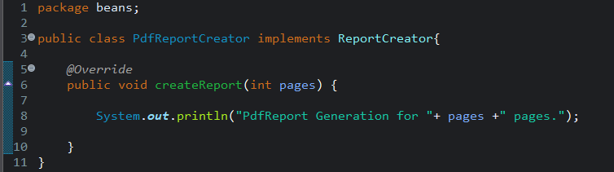

ExcelReportCreator.java
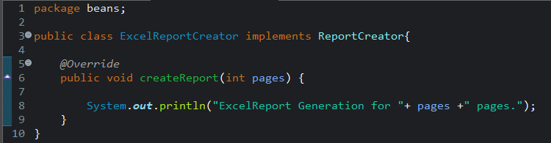

ReportManager.java
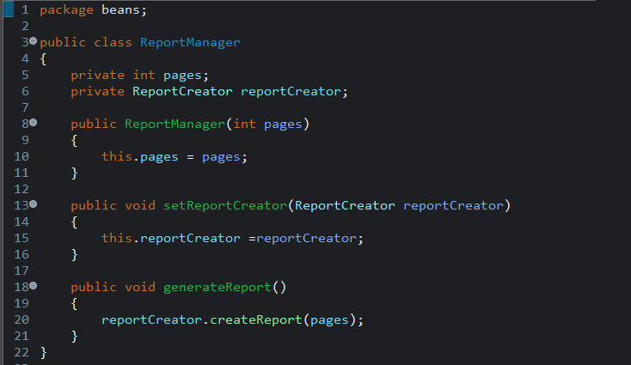

App.java
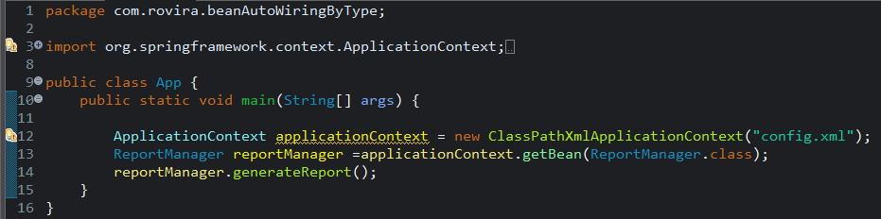

config.xml
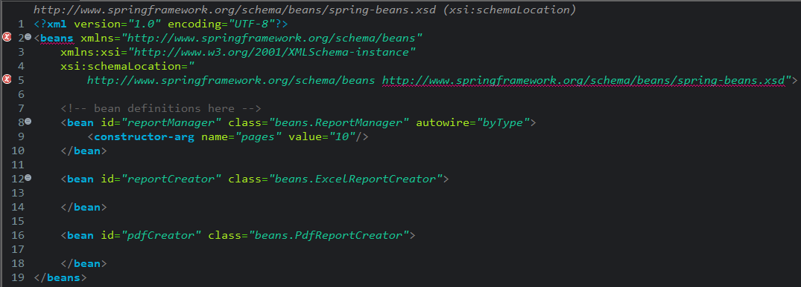
Output
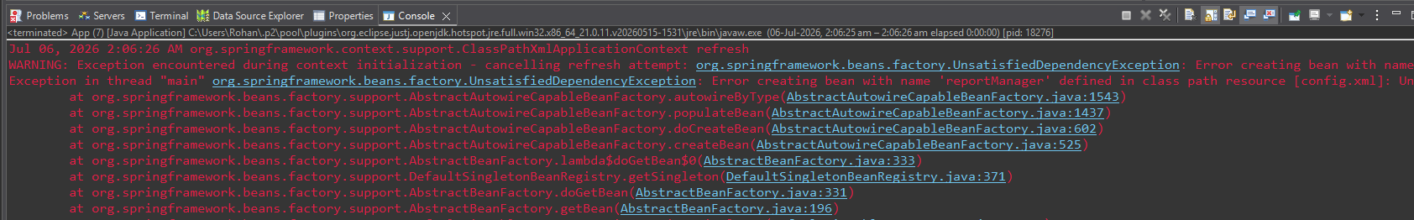

Problem:
-ReportManager needs a ReportCreator bean, and autowiring is set to byType.
-Two beans (ExcelReportCreator, PdfReportCreator) match that type.
-Spring finds two matching candidates and can't decide which one to inject → throws UnsatisfiedDependencyException (caused by NoUniqueBeanDefinitionException — "expected single matching bean but found 2").

Solution:
-Added primary="true" to the ExcelReportCreator (or PdfReportCreator)bean definition in config.xml.
-This tells Spring: "when there's ambiguity between multiple type-matching beans, prefer this one."
-byType autowiring resolves without ambiguity — ExcelReportCreator gets injected into ReportManager.
-App runs successfully, printing the Excel report output.

Solution
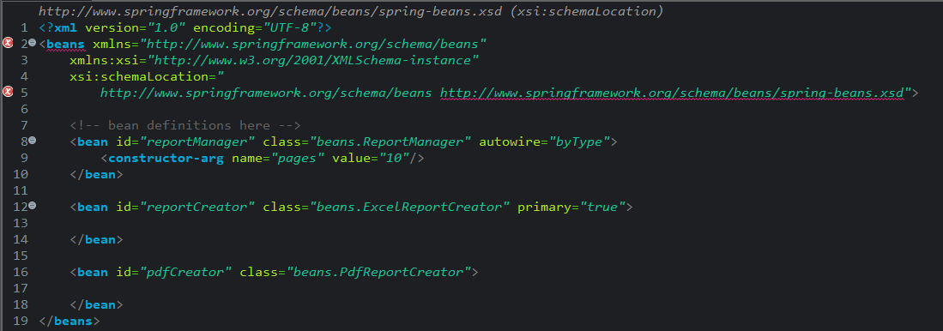

Output
